OEM setup on servers gbbed26db01vcn1/2

Go to setup 🡪 Add target 🡪 Add targets manually

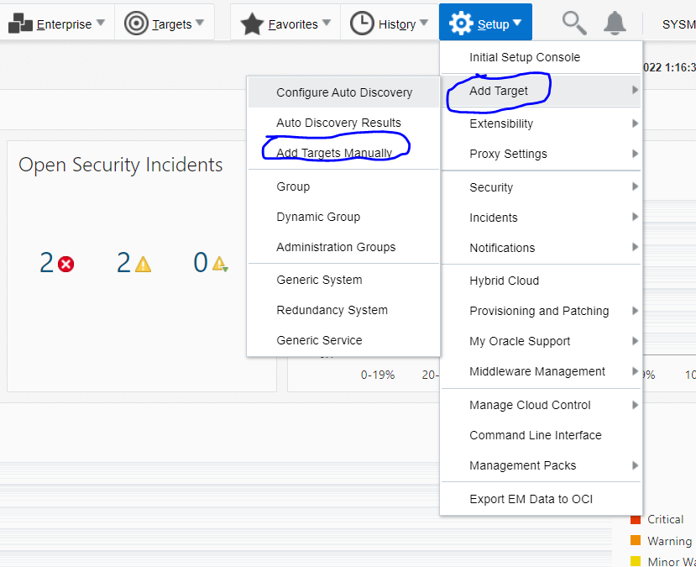

Click on Add using guided process

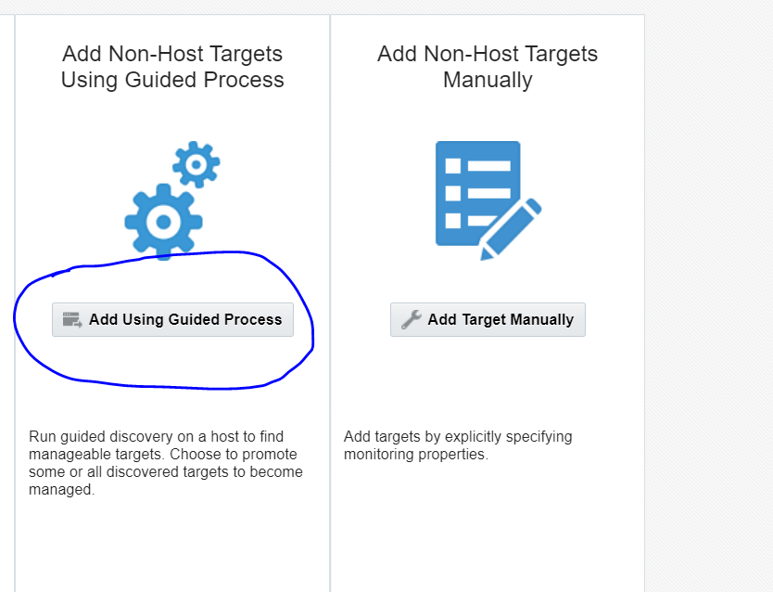

We will first add Oracle cluster and HAS, Below is the screenshot.

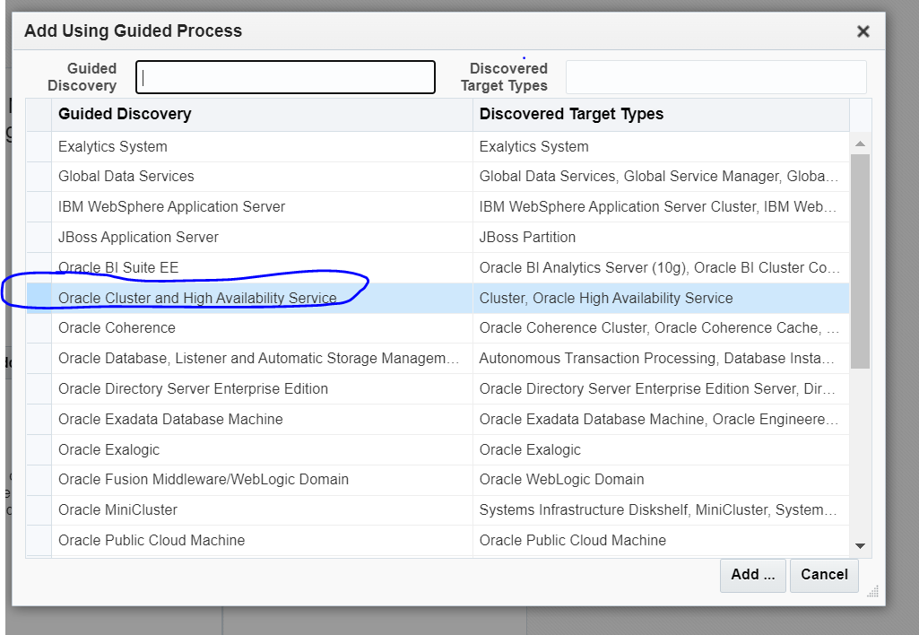

Click on search and then put hostname (node 1 hostname in case of RAC)

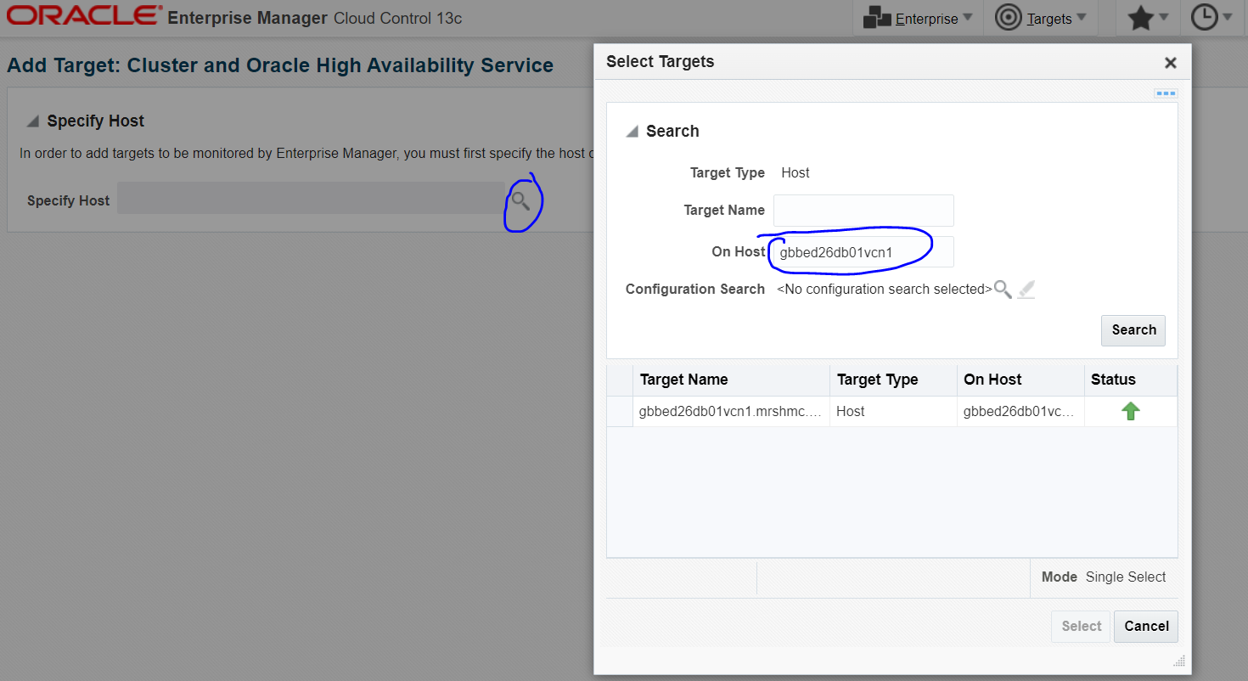

Click on discover targets , it will automatically detect targets.

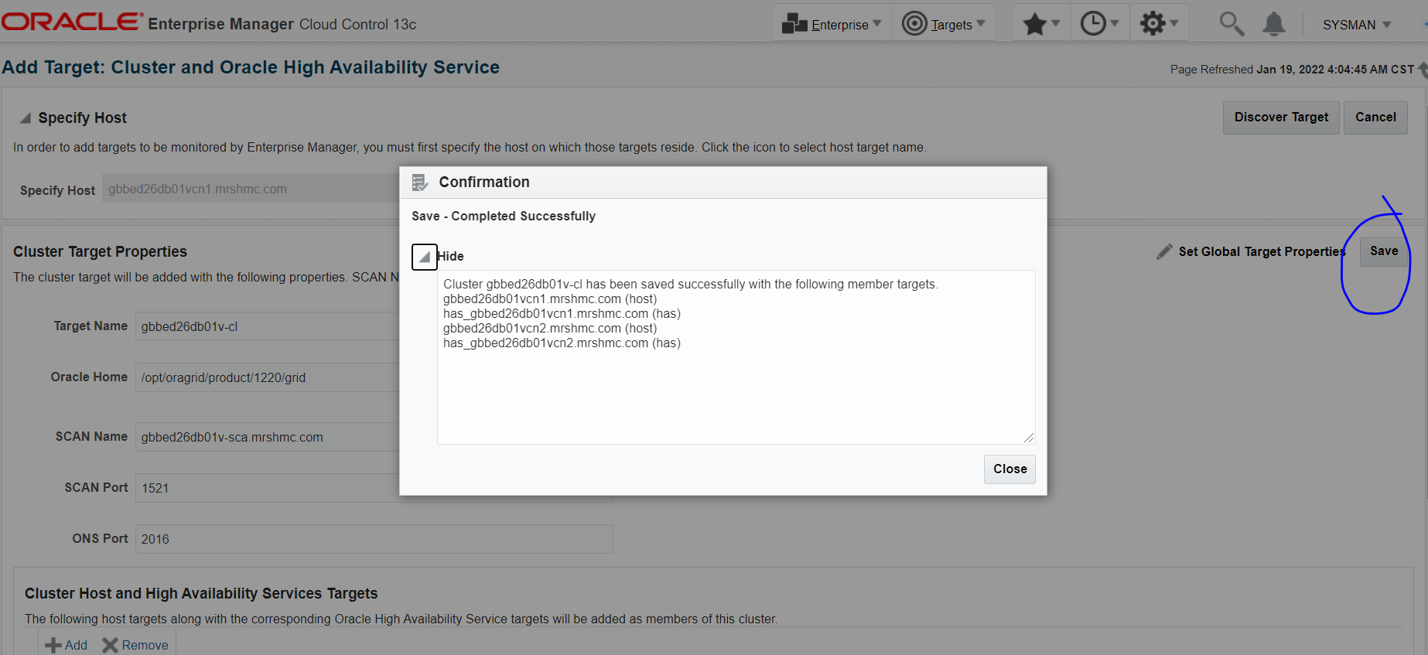

Search with the hostname and cluster will be added , check below

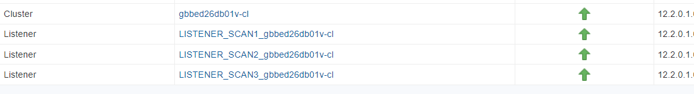

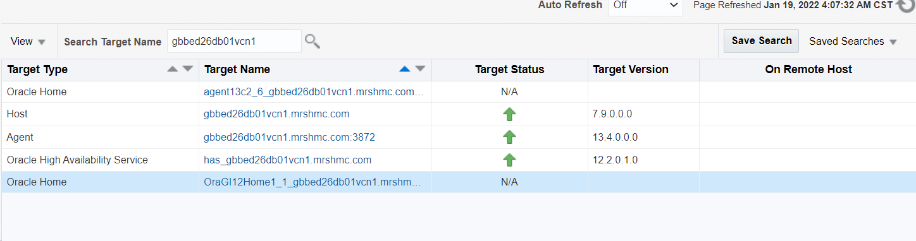

Again go to guided process, now we will add DB , listener and ASM.

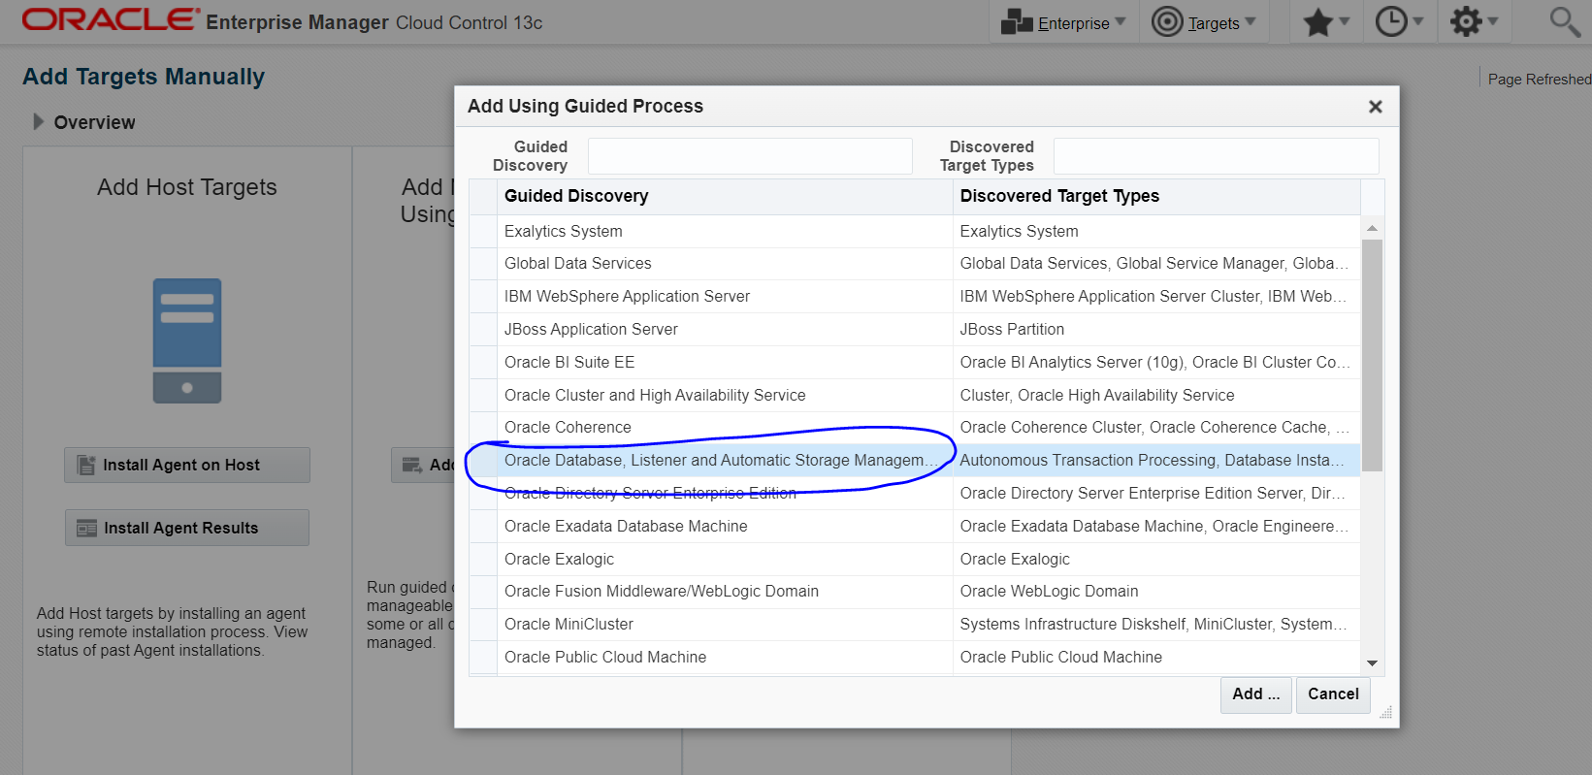

This time in search , we will add targets with the help of cluster. (check below)

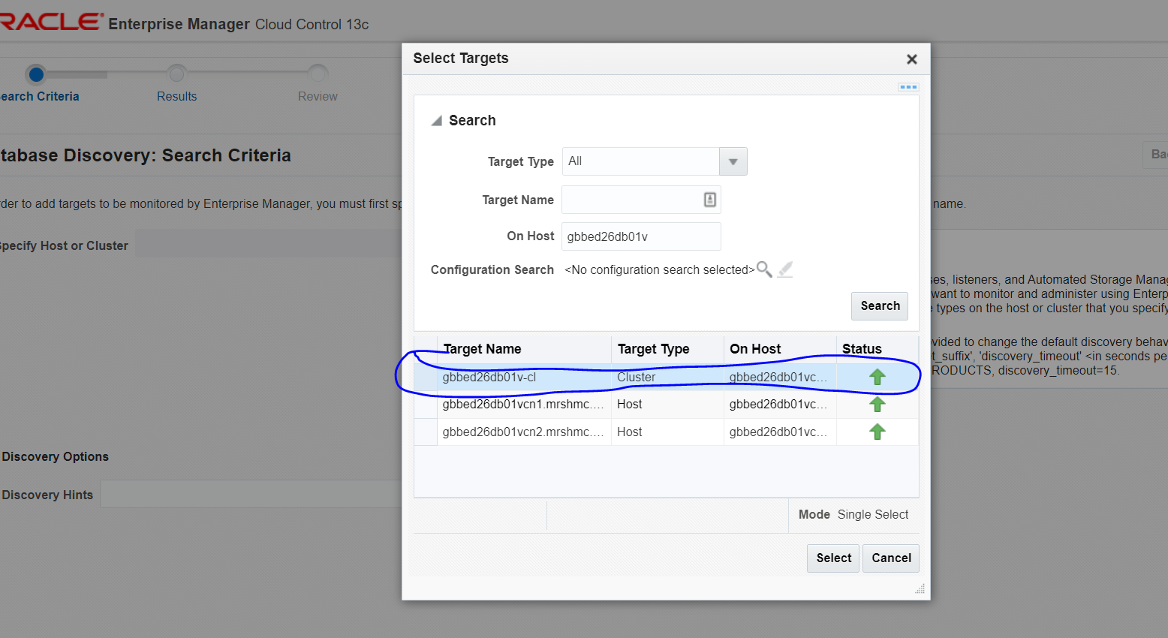

Click on next

It will discover targets as below

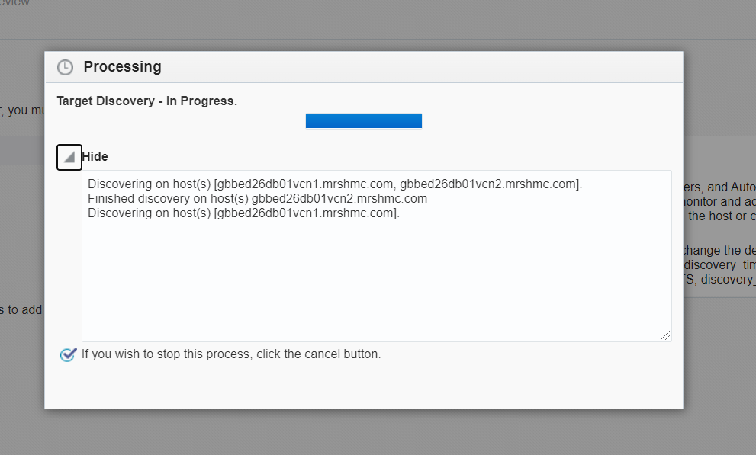

Put the dbsnmp and asmsnmp password and add targets to prod/Non-prod group.

Then click on next and save,Targets would get added.

It should be like below.

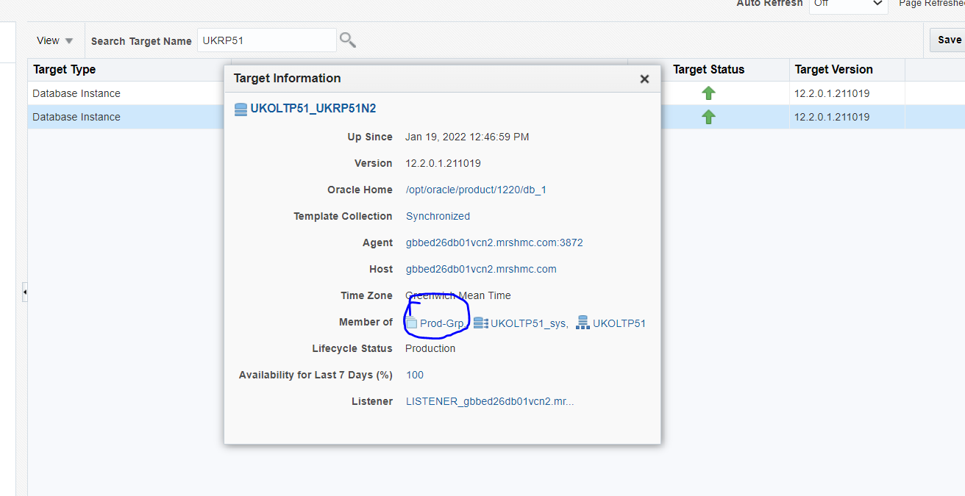

Let me know in case of any issue.DOC made by AMANDEEP GERA